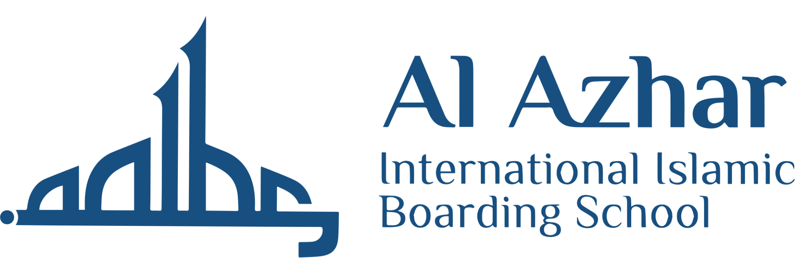

Visit Request Form

IMPORTANT to note:
- All sections must be completed in full.
- The completed form should be submitted to humas.aaiibs@gmail.com at least 14 days prior to the date of your proposed visit.
- Requests submitted by agents (including travel agents) will not be accepted.
- Student groups/institutions seeking a visit or campus tour are requested to:
- Contact the International Affairs & Public Relation Centre at humas.aaiibs@gmail.com / Tel: +62 882-2138-7186 (applicable to requests from schools, international & local universities, foundations, and any organizations)
- Contact the Enrollment Centre at enrollment.aaiibs@gmail.com / Tel: +62 811-1355-011 (applicable to enrollment & admissions matters)
- If you have any questions, please contact at elareive85@gmail.com
__________________________________________________________________________________________

Date of Proposed Visit : _________________ (dd/mm/yyyy)
Time of Proposed Visit : _________________ (a.m./p.m.)

Person Making the Visit Request:
Title (Prof./Dr./Mr./Ms.) | First Name |  | Last Name
Position
Organisation
Organisation’s Website
Email
Contact information | Tel: | Mobile: |  | Fax:

Overview of the Institution / Organisation:
(Background, strengths, centres of excellence (if any), etc.)

Objectives of the Visit:

- Information of Al Azhar IIBS  - Student / Staff Exchange  - Admission / Academic Matters | - Research  - Academic Promotions  - Collaboration
- Other (Please specify):

Topics of Interest for Discussion:
(Please specify clearly to enable us to ensure that relevant offices are represented at the meeting)

Do you have any previous association with the Al Azhar International Islamic Boarding School?
(If yes, please specify)

Person(s) You Would Like To Meet:
Name | Designation

Total number of delegates:

Leader of Delegation / Visiting Group:
(Kindly provide CV or biography)
Title (Prof./Dr./Mr./Ms.) | First Name | Last Name | Position

Information of Delegates / Visitors:
(Kindly include all members of delegation to facilitate seating arrangements)
Title (Prof./Dr./Mr./Ms.) | First Name | Last Name | Position

The delegation’s contact person whilst:
Name | Designation | Mobile Number

For your delegation to receive maximum benefit from their visit, they should either have a working knowledge of English or be accompanied by an interpreter. Al Azhar International Islamic Boarding School is not able to provide interpretation services.
Name of Interpreter

Thank you for completing the Visit Request Form.
Should you have any queries, please send us an e-mail at humas.aaiibs@gmail.com

